EXPERIMENT 03
TITLE: Creation of Simple Network Topology using Mininet

AIM: To create a simple network topology using an open-source network virtualization tool (Mininet).

OBJECTIVE:
1. To install Mininet
2. To create topology - single switch with 3 hosts
3. To verify connectivity using Linux commands
4. To stop the network

SOFTWARE USED:
Oracle VirtualBox, Ubuntu 22.04, Mininet 2.3.0

THEORY:
Mininet is a network emulator which creates virtual hosts, switches, controllers and links on a single Linux machine. It uses Open vSwitch. Command sudo mn --topo single,3 creates a topology where 3 hosts are connected to 1 central switch.

PROCEDURE & EXECUTION:

1. Install Mininet
sudo apt update
sudo apt install mininet -y
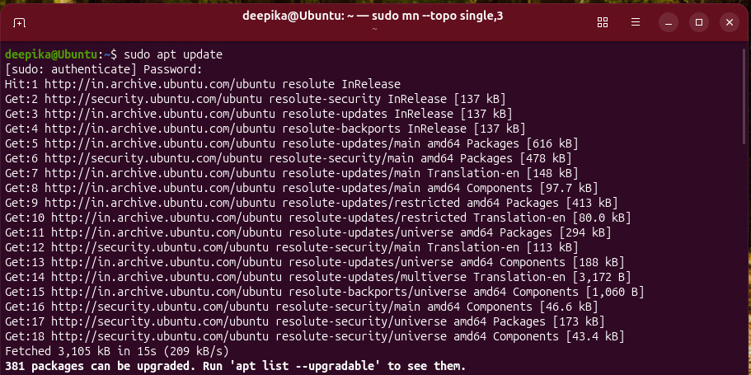
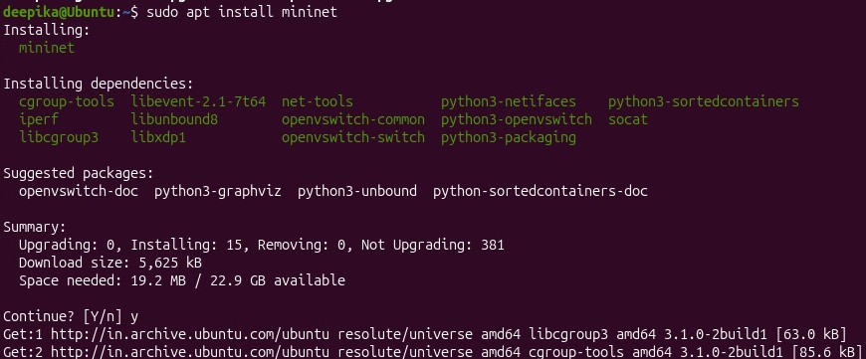

2. Create Topology
mn --version
sudo mn --topo single,3
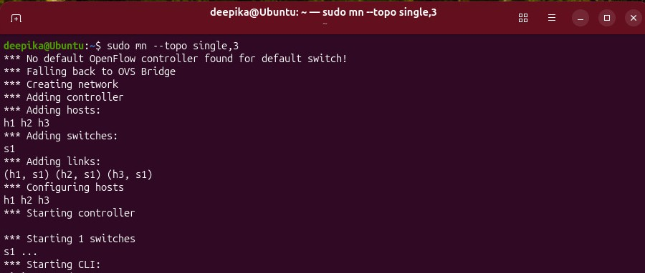
3. Verify Network
mininet> nodes
available nodes are: h1 h2 h3 s1

mininet> net
h1 h1-eth0:s1-eth1
h2 h2-eth0:s1-eth2
h3 h3-eth0:s1-eth3

mininet> pingall
Results: 0% dropped (6/6 received)
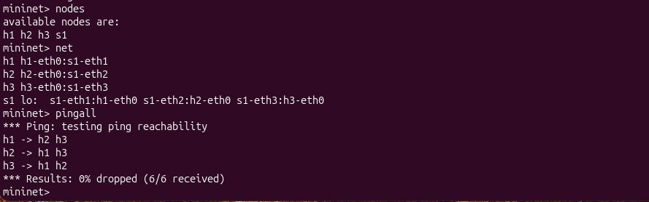

4. Stop Network
mininet> exit
sudo mn -c
Output: Cleanup complete
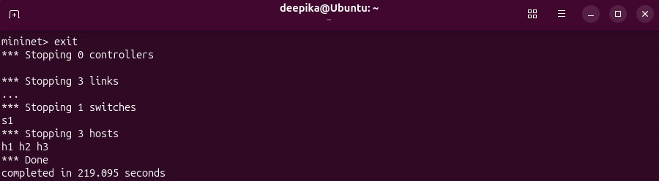
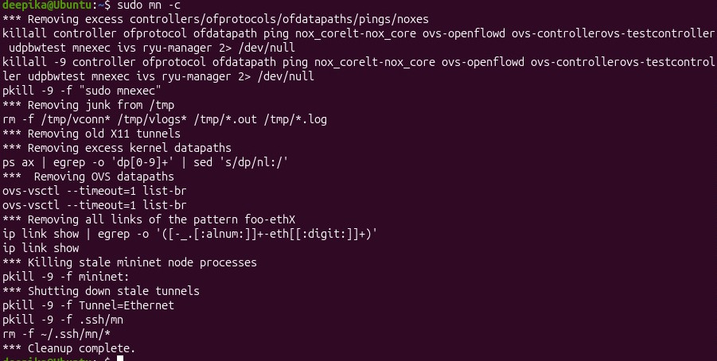

RESULT:
Successfully created virtual network with 1 switch and 3 hosts and verified communication. pingall showed 0% packet loss.

CONCLUSION:
We learned to create and configure virtual networks using Mininet, an open-source tool, and verified it using Linux networking commands.

